# MySQL Workbench and MySQL Server Windows Installation Guidelines

This document consists of guidelines for installing MySQL server. The installation file for Windows can be downloaded from [here](https://dev.mysql.com/downloads/installer/).

## Step 1. Download MySQL Community Server

Go to the MySQL web site and download MySQL Community Server. The link given above should redirect you to the official MySQL webpage where you can find a link to downloading the MySQL Community Server Installer.

Click the "Download" button corresponding to your OS. Keep in mind that you should always choose the latest version, which might be different from the current tutorial.

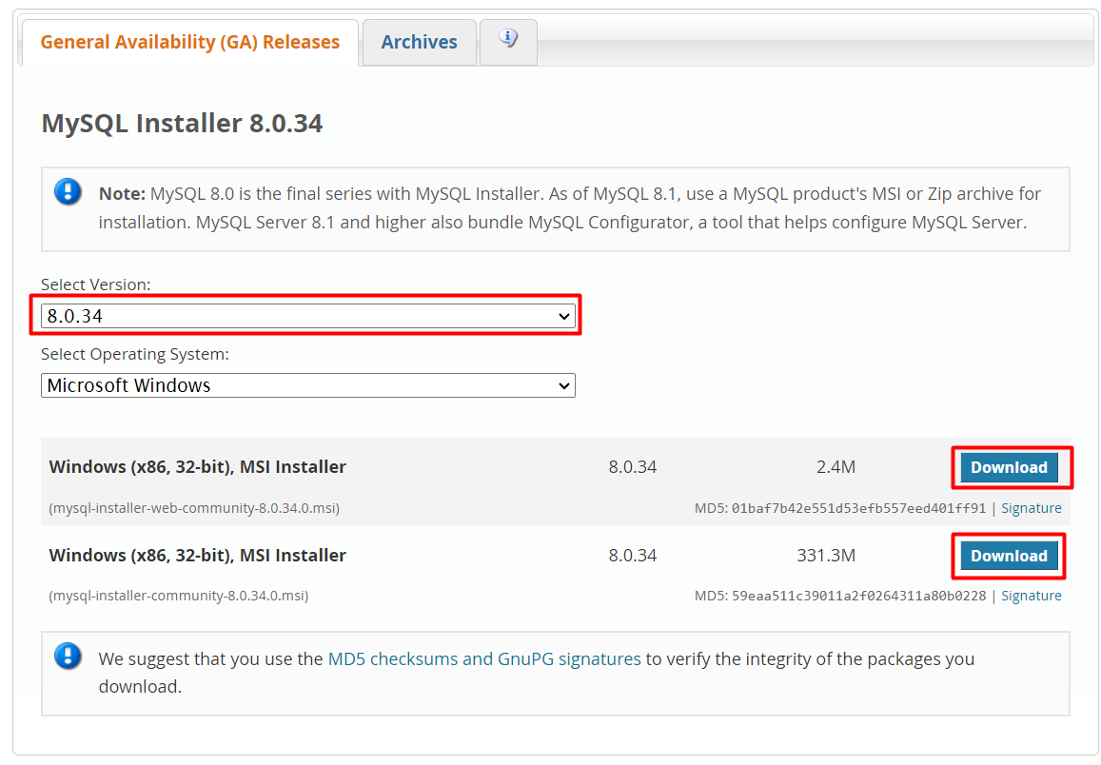

## Step 2. Install the MySQL Community Server

1. Open installation file and choose the **Setup type** to be **Custom**. Then click **Next.**

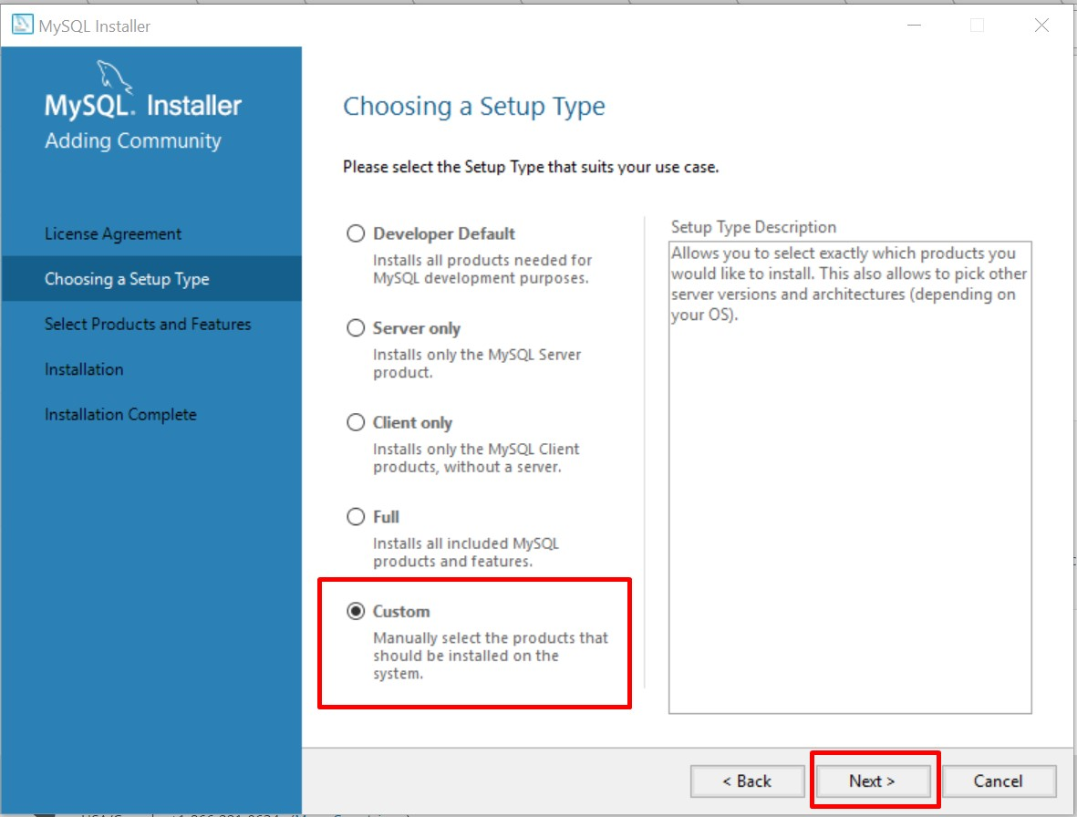

1. All the features we need are **MySQL Server**, **MySQL Workbench, Connector/J**, **Connector/NET and MySQL Workbench**. All other features are optional and won’t be needed for that course.

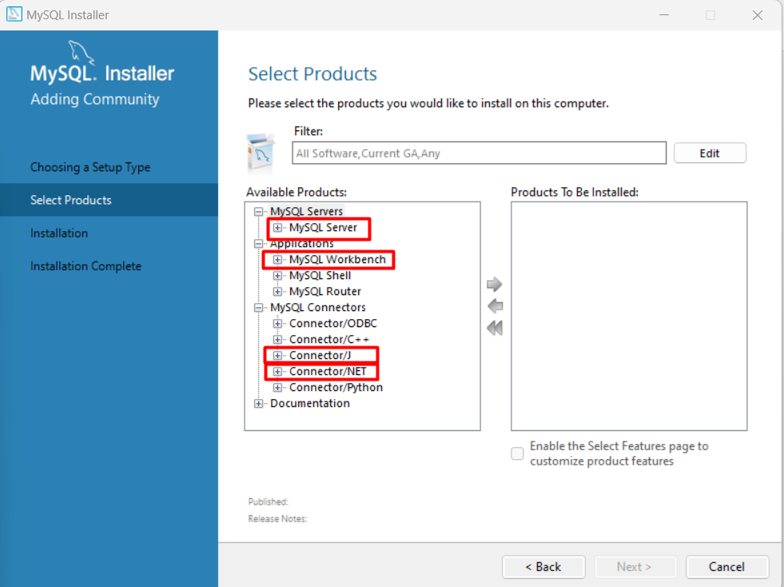

1. Each of these features have sub-folders and you should navigate to the latest version, which you want to install. Again, keep in mind that the version might be different than in the current tutorial!

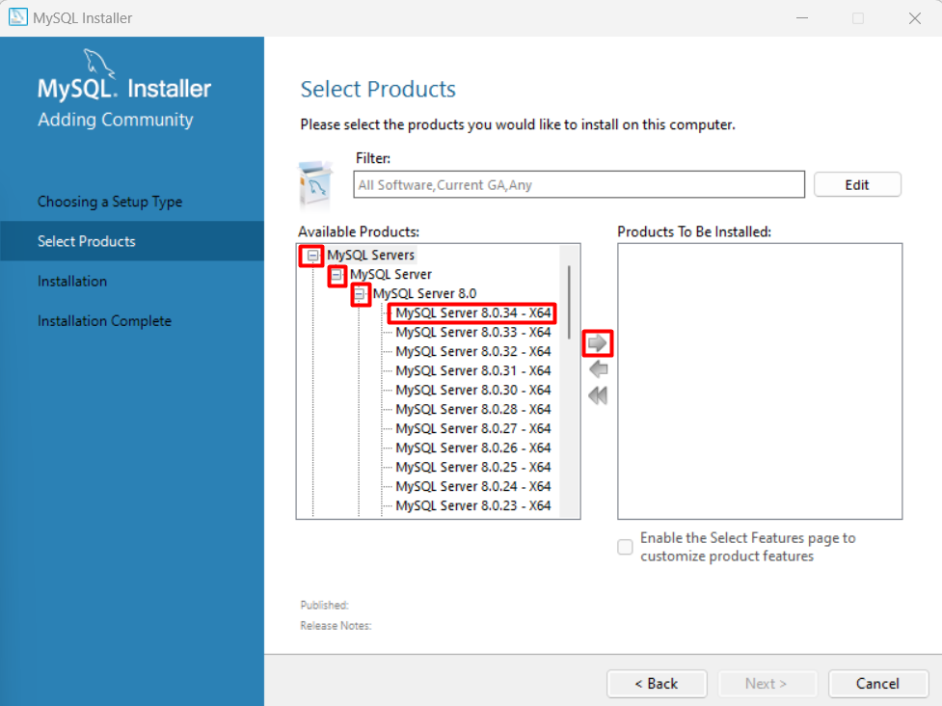

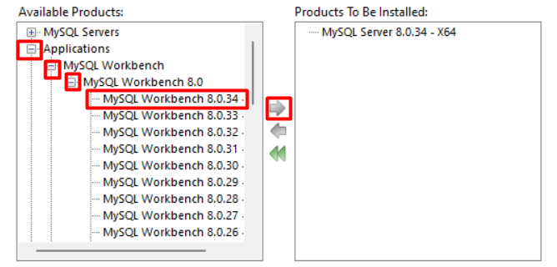

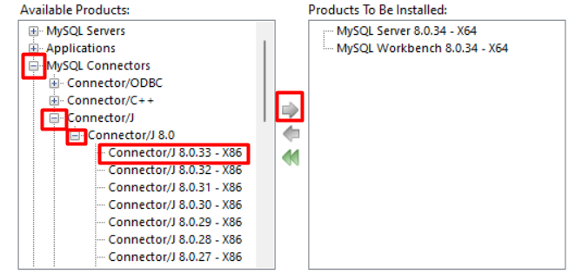

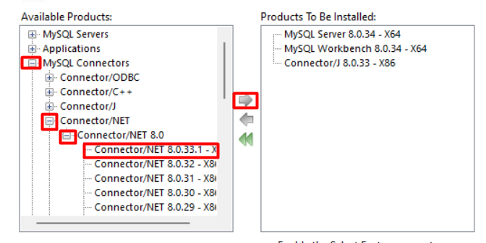

1. Finally, the chosen features should look like this and you should click **Next**.

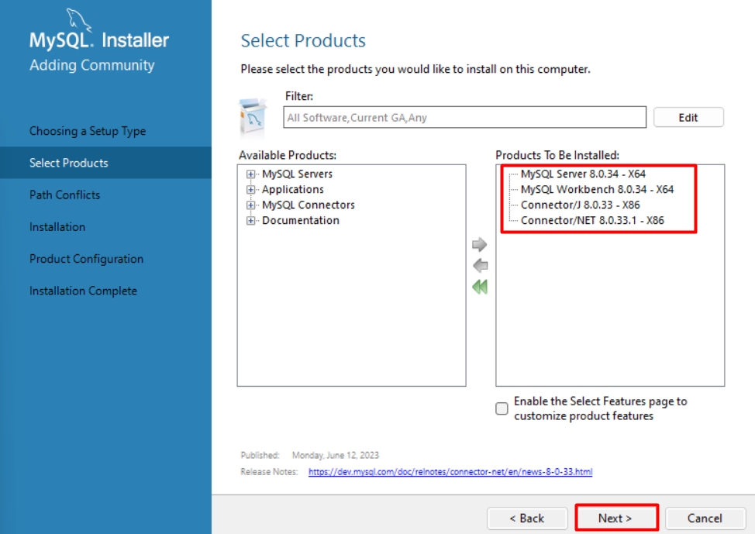

1. Click **Execute** and the setup will install the chosen features.

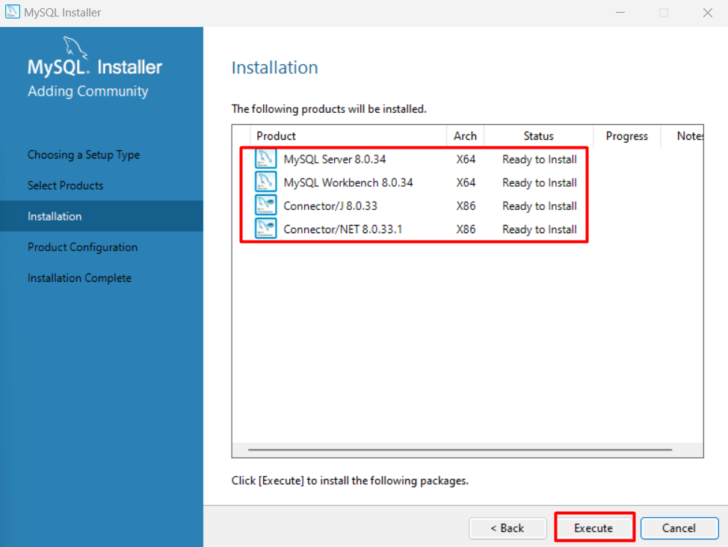

1. Wait all features to be complete:

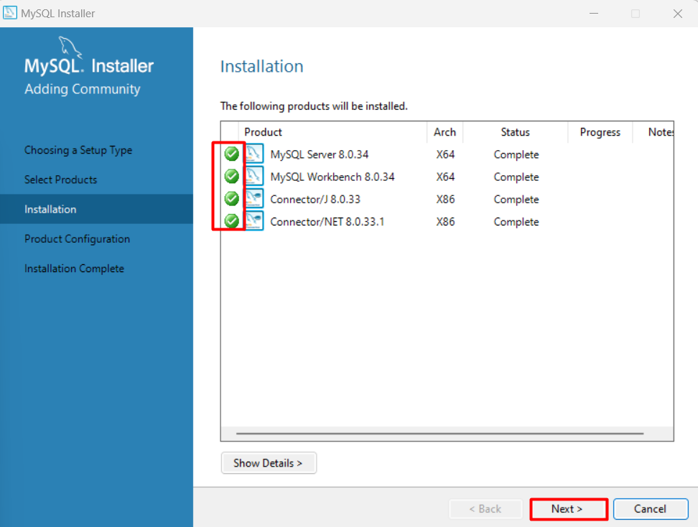

1. And again, hit **Next** to enter the configuration settings.

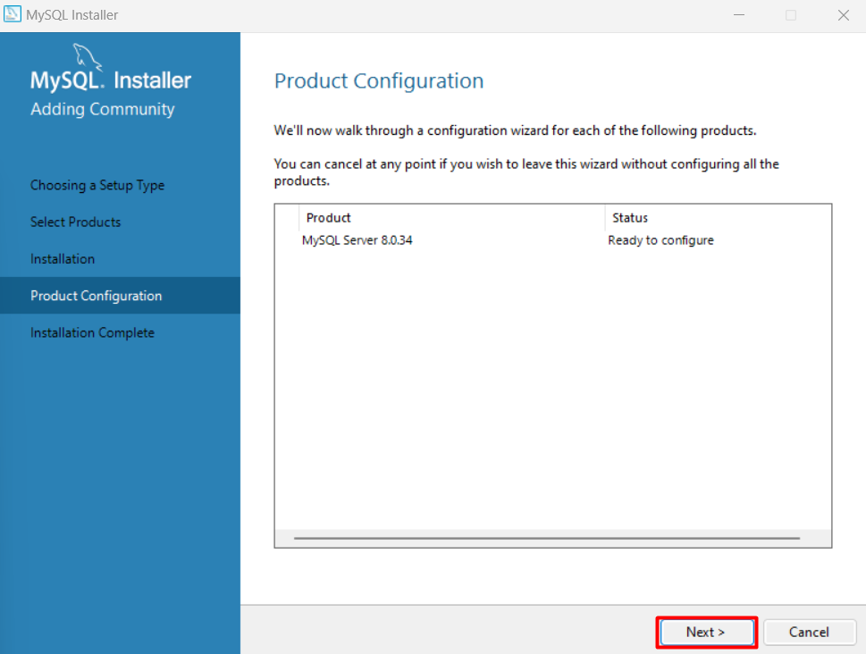

1. Choose the configuration type to be a **Development Computer** and click on Next.

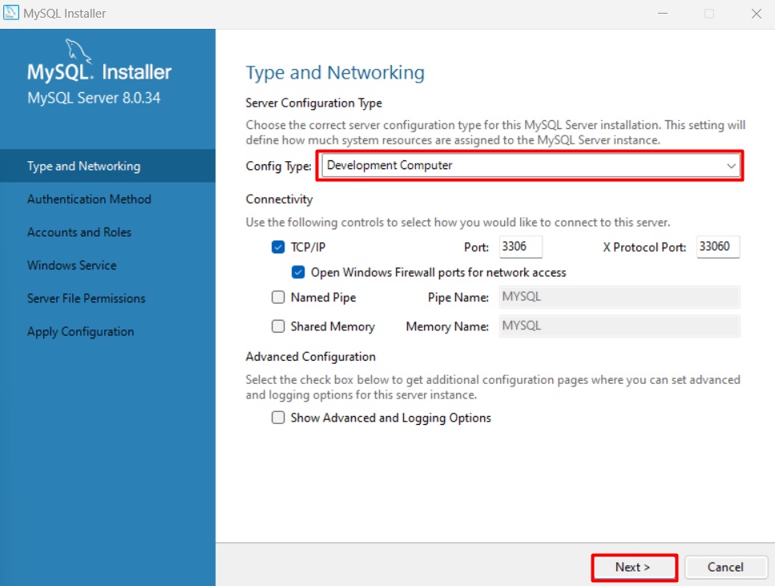

1. Choose **Authentication Method.**

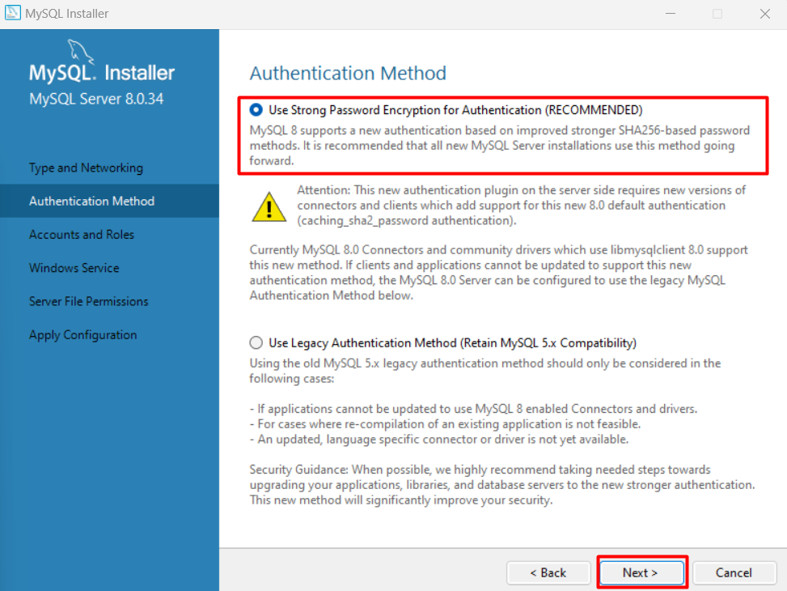

1. Set **password to the Root account**.

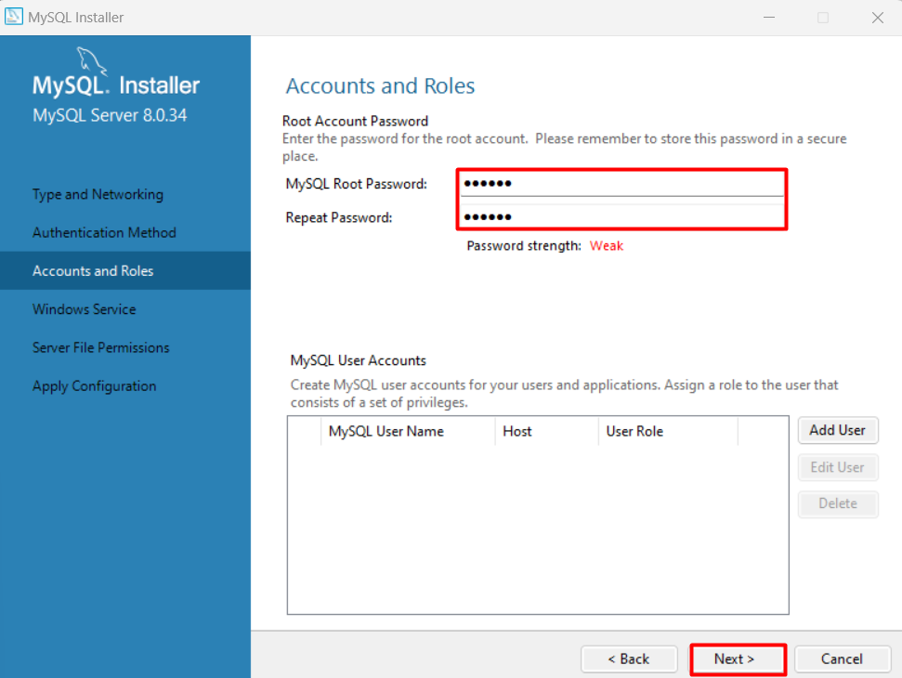

1. Here you can set the **MySQL Server** to run as **Windows Service** and to start automatically at Windows start up. This is the recommended way. Otherwise, you have to start MySQL manually every time before working with the database.

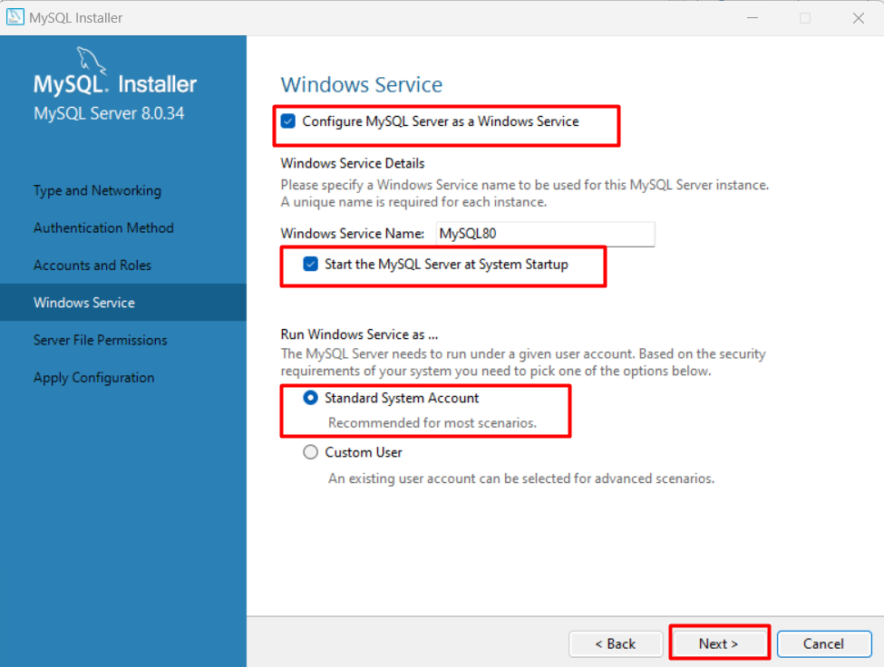

1. Grant Permissions. **If you’re not sure what to do here, just leave it as it is.**

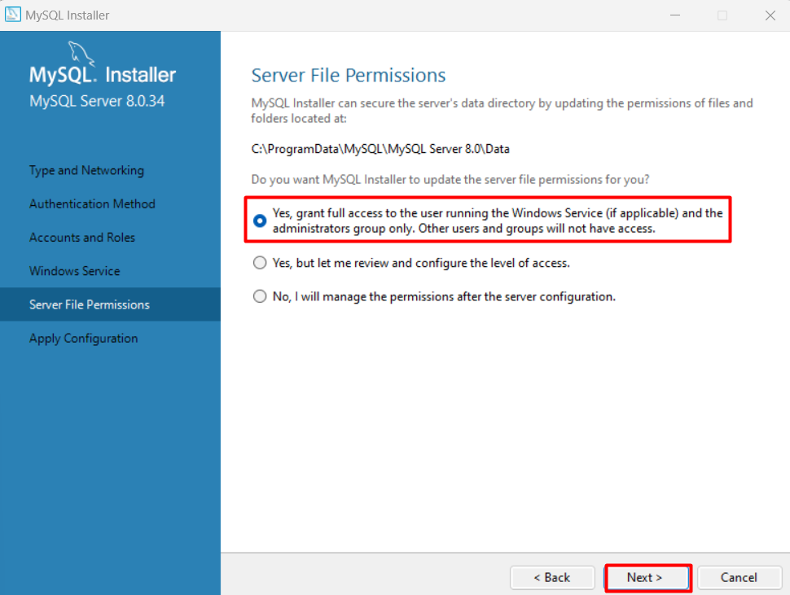

1. Click **Next, and then Next** to Apply the configuration.

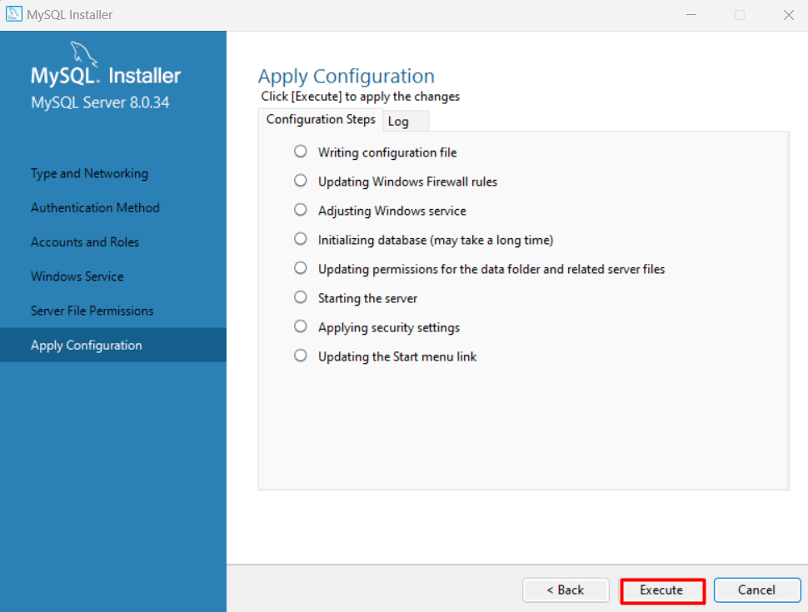

1. Click **Finish**.

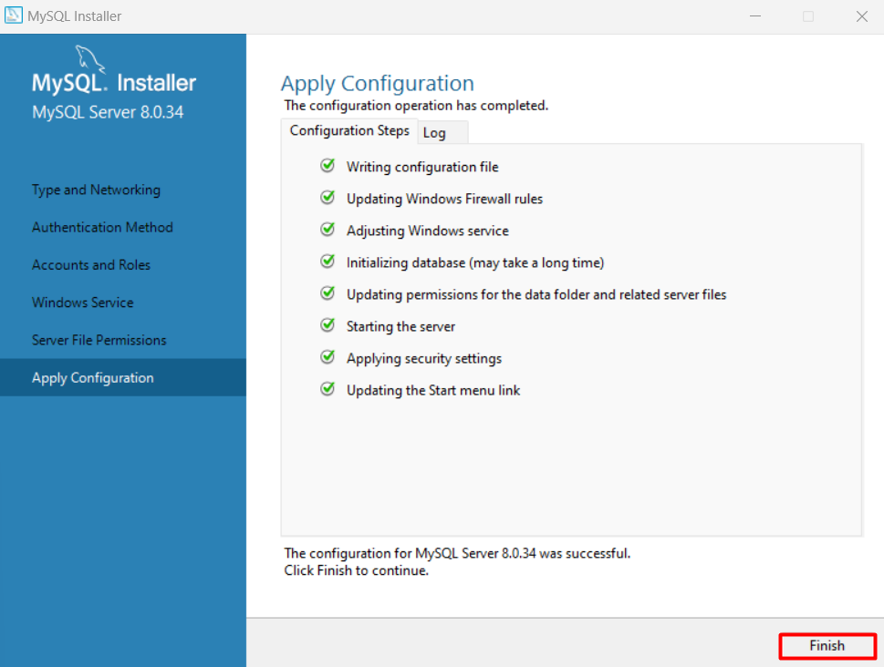

1. Again, Next to confirm product configuration. And again, **Finish** to start Workbench.

